LGE Internal Use Only

LGE VS [OEM NAME] [PROJECT NAME]

Test Master Plan (TMP)

About This Template
- Template Name: LGE_VS_SysT_T01_TMP(Test Master Plan)
- Management Department: VS SW Process Team
- Revision History
Version | Date | Comment | Author
2.0 | 2017-10-16 | Initial Release  - Modified from LGE_VC_Template_TMP(Test_Master Plan_v1.0 to comply with A-SPICE 3.0 and ISO 29119 | VC Smart SW Process Team  LG Electroincis
2.1 | 2019-03-08 | Update due to annual organization restructuring (VC --> VS) | VS Smart SW Process Team
2.2 | 2021-08-06 | Updated security notice of this template (Before: LGE Confidential->After: LGE Internal Use Only)  Security level related note (the last sentence in red color below) | VS Smart SW Process Unit

Read me first
- This template is a basic form for the Software Unit Test Plan document, consisting of a preparation guideline (geen box) and an example.
- Read and understand the contents of General Guidelines before writing a document.
- Delete all preparation guidelines (green boxes) after completing the document.
- Since the content composition of this template may not fit 100% of all projects, tailoring should be used to suit the size and characteristics of the project.
- Use the term Item in the test area with regard to terms. That is, the terms Element, Component of the development phase are not used.
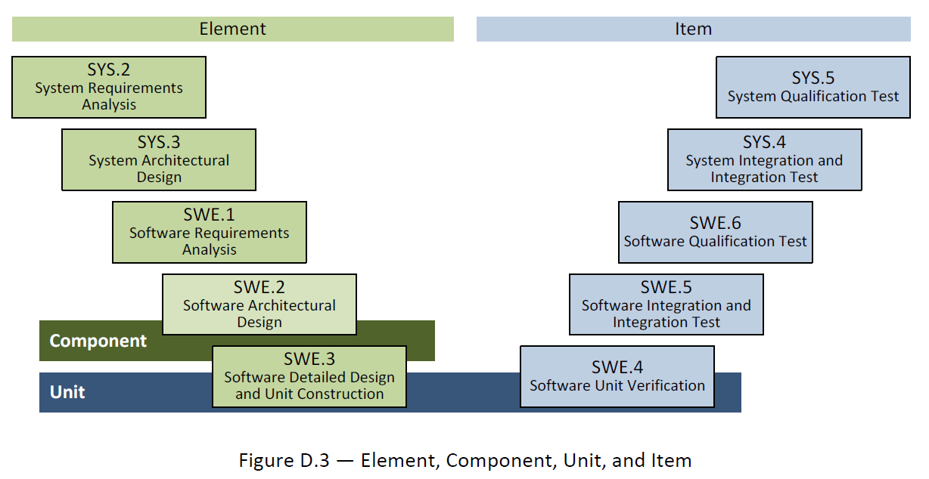
- The notice “LGE Internal Use Only” is for this template itself. The document which use this template needs to be classified as suitable security level according to its content.

General Guidelines
- Ground Rules for TMP
- This Test Plan for each test area is to validate each development area.
That is, the targets and criteria for testing areas are planned based on the corresponding development areas.
- TMP is tailoring in consultation with concerned staff according to project status.
- Seven Rules
- Write from the reader's point of view..
- Avoid unnecessary repetition of information in the document.
- Make sure there is no ambiguity in the document. Clearly specify the meaning of the notation used in the diagram.
- Use the standard structure of the document. Create an easy-to-reference structure. Don't leave the blank for difficult parts and mark them "to be metered."
- Record the reasons for adopting the test. It is useful for future reviews or changes.
- Do not reflect the changes immediately on the document. Instead, reflect the changes according to the document's version control and release schedule.
- Ask the target reader for a review.
- References
This template has been revised by referring to the following test related technical data and the TMP template and guide document which have been distributed in the past.
- Automotive_SPICE_PAM_v3.0
- ISO/IEC/IEEE 29119 Software Testing Standard
- ISO/IEC/IEEE 25010:2011 Systems and Software Engineering
- Previously deployed TMP templates and guidelines from VS
- Document Format
If you use this template, you don't have to worry about document forms. Follow the basic rules below.
- Body font : Clear Gothic
- Give numbers and titles to all pictures and tables and make them easy to mention.
- Automatically insert captions : Select a figure or table from [Reference] > [Captition In] > [Label] in woad and select OK.
- Caption location :
Insert caption below picture : Figure 1 picture titl, Figure 2 picture titl, ..
Insert captions over table : Table 1 table title, Table 2 table title, ..
- Document Versioning, File Naming Rule
See the section 'Naming Rules for Document Output' in the Configuration Management Guideline (LGE_VS_Guideline_Form Management) managed within a project.
About This Document
Document Information
Issuing authority | VS OOO Team
Configuration ID | Configuration Item ID in CMBook
Status of document | In Progress / Approved / Released

Revision History
Describe the purpose of this document.

Verion | Date | Comment | Author | Approver
#.# | YYYY-MM-DD | OOOOOOO | OOO | OOO

Purpose
Describe the purpose of this document.
This document is the test plan of the [project name] project.
Scope
Describe the scope of this document.
This document contains the following.
- Test strategy
- Scope of Test
- Quality goals
- Roles and responsibilities
- Test methodology
- Exam Schedule
- Test products
- Measurements
- Regression testing
- Test standards
- Test environment
- Test constraints
- Examination risk
Audience
Describe the related stakeholders who have the authority to read this document.
This document is intended to be viewed as follows:
- Project Manager
- Project Leader
- Project Sub-leader
- SW Engineer
- HW Engineer
- Test Engineer
- Configuration Manager
- Requirement Manager

Related Documents
Describe the relevant documents with this document.
The documents related to this document are as follows:
- LGE_[OEM]_[Project name]_TMP
- LGE_[OEM]_[Project name]_SWUTP
- LGE_[OEM]_[Project name]_SWITP
- LGE_[OEM]_[Project name]_SWTP
- LGE_[OEM]_[Project name]_SysITP
- LGE_[OEM]_[Project name]_SysTP
- LGE_[OEM]_[Project name]_SWUTC
- LGE_[OEM]_[Project name]_SWITC
- LGE_[OEM]_[Project name]_SWTC
- LGE_[OEM]_[Project name]_SysITC
- LGE_[OEM]_[Project name]_SysTC
- LGE_[OEM]_[Project name]_PMP
- LGE_[OEM]_[Project name]_CMP
- LGE_[OEM]_[Project name]_CMBook
- LGE_[OEM]_[Project name]_WBS
- LGE_[OEM]_[Project name]_PRM

Conventions and Acronyms
Conventions
Describe the reference for convenience and need-to-know information as follows

NOTE
Reference for convenience

CAUTION
Important notes that you must know among contents

Acronyms

Acronym | Description
TMP | Test Master Plan
SysTP | System Qualification Test Plan
SysT | System Qualification Test
SysITP | System Integration Test Plan
SysIT | System Integration Test
SWTP | Software Qualification Test Plan
SWT | Software Qualification Test
SWITP | Software Integration Test Plan
SWIT | Software Integration Test
SWUTP | Software Unit VerficiationPlan

Table of Contents
1 Plan Context 1-1
1.1 Project 1-1
1.1.1 Overview 1-1
1.1.2 System Architecture Diagram 1-1
1.1.3 Software Architecture Diagram 1-2
1.2 Test Scope 1-2
1.3 Assumptions and constraints 1-5
1.3.1 Organizational Constraints 1-5
1.3.2 Project Constraints 1-5
1.3.3 Contractual Constraints 1-6
1.3.4 Regulatory / Legal Constraints 1-6
2 Testing Communication 2-7
2.1 Stakeholders 2-7
2.2 Communication plan 2-7
3 Risk Register 3-8
3.1 Project Risks 3-8
3.2 Product Risks 3-8
4 Test Strategy 4-10
4.1 Test Process 4-11
4.2 Test Deliverables 4-11
4.2.1 Test Cases 4-11
4.2.2 Test Results Report 4-12
4.2.3 Test Plan 4-13
4.3 Reviews 4-14
4.3.1 Testability Review 4-14
4.3.2 Test Case Conformity Review 4-15
4.4 Test Design Techniques 4-15
4.4.1 Software Code Review (Example) 4-15
4.4.2 Static Testing (Example) 4-15
4.4.3 Specification Based Testing 4-15
4.4.3.1 State Transition Testing (Example) 4-16
4.4.3.2 Scenario Testing (Example) 4-16
4.4.4 Structure Based Testing 4-16
4.4.5 Experience Based Testing 4-17
4.4.5.1 Ad-hoc Testing (예시) 4-17
4.4.5.2 Exploratory Testing (예시) 4-17
4.4.6 Qualification Testing 4-18
4.4.6.1 Performance (Example) 4-18
4.4.6.2 Accessibility (Example) 4-18
4.5 Test Entry / Completion Criteria 4-18
4.5.1 Entry Criteria 4-18
4.5.2 Completion Criteria 4-19
4.5.3 CCB Completion Criteria 4-19
4.6 Metrics to be collected 4-19
4.6.1 The Metrics of Measurement Analsysis 4-20
4.6.2 The Metrics of Test Cases Develoment Plan 4-20
4.7 Retesting and Regression Testing 4-20
4.8 Test Tools 4-22
4.8.1 SW Testing Tools 4-22
4.8.2 HW Testing Tools 4-22
4.9 Configuration Management 4-23
5 Staffing 5-24
5.1 Roles, activities, and responsibilities 5-24
5.2 Training needs 5-24
6 Schedule 6-25

Figures
Figure 1-1 ADAS Front Mono Camera for MY20 C Class 1-1
Figure 1-2 Test Scope 1-3
Figure 4-1. Bidirectional Traceability and Consistency of A-SPICE PAM 3.0 4-10
Figure 4-2. Test Process 4-11
Figure 4-3. Requirements Testability Review 4-14

Tables
Table 1-1 System Elements 1-4
Table 1-2 SW Components & Major Function 1-4
Table 3-1 Project Risks 3-8
Table 3-2 Product Risks 3-9
Table 4-1 Test Cases 4-12
Table 4-2 Test Results Report 4-13
Table 4-3 Test Plans 4-13
Table 4-4 Test Techniques of Specification Based Testing 4-16
Table 4-5 Test Techniques of Structured Based Testing 4-17
Table 4-6 Test Techniques of Experience Based Testing 4-17
Table 4-7 Entry Criteria 4-19
Table 4-8 Completion Criteria 4-19
Table 4-9 CCB Completion Criteria 4-19
Table 4-10 The Metrics of Measurement Analysis 4-20
Table 4-11 The Metrics of Test Cases Develoment Plan 4-20
Table 4-12 Retesting and Regression Testing 4-21
Table 4-13 SW Testing Tools 4-22
Table 4-14 HW Testing Tools 4-23
Table 6-1 Schedule 6-25

Plan Context

Project

Overview
Provides an overview of the Project
Include related Collab Link information and visualize it

This project is the development of ADAS front camera for Daimler's MY20 C class.
As a functional safety requirement, ASIL B must be satisfied.
See the PMP ^{Project Master Plan} document.
(http://val.lge.com/ivi/svn/DAI_MPC5_5/trunk/02_Project%20Management/02_Plan/01_Project_Management_Plan/).

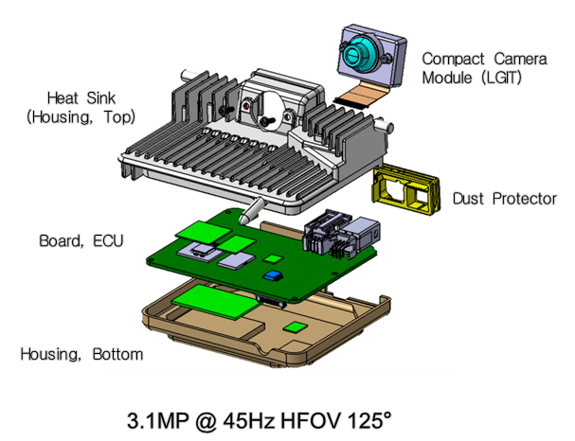
Figure 1-1 ADAS Front Mono Camera for MY20 C Class

System Architecture Diagram
See System Architecture Design (with links)

See the SysAD ^{System Architecture Design} .
(http://val.lge.com/ivi/svn/DAI_MPC5_5/trunk/03_SW_Engineering/02_System_Design/01_System_Architectural_Design)

Software Architecture Diagram
See Software Architecture Design (with links)

See SAD ^{Software Architecture Design} .
(http://val.lge.com/ivi/svn/DAI_MPC5_5/trunk/03_SW_Engineering/03_SW_Design/01_SW_Architecture_Design)

Test Scope
Define the scope developed by LG as Test Scope and explain it
For each test area, refer to separate test plan document for each test area

System diagrams consist of system elements. Test subjects relate to system elements developed by LG.
Figure 1 shows the system design and system elements.
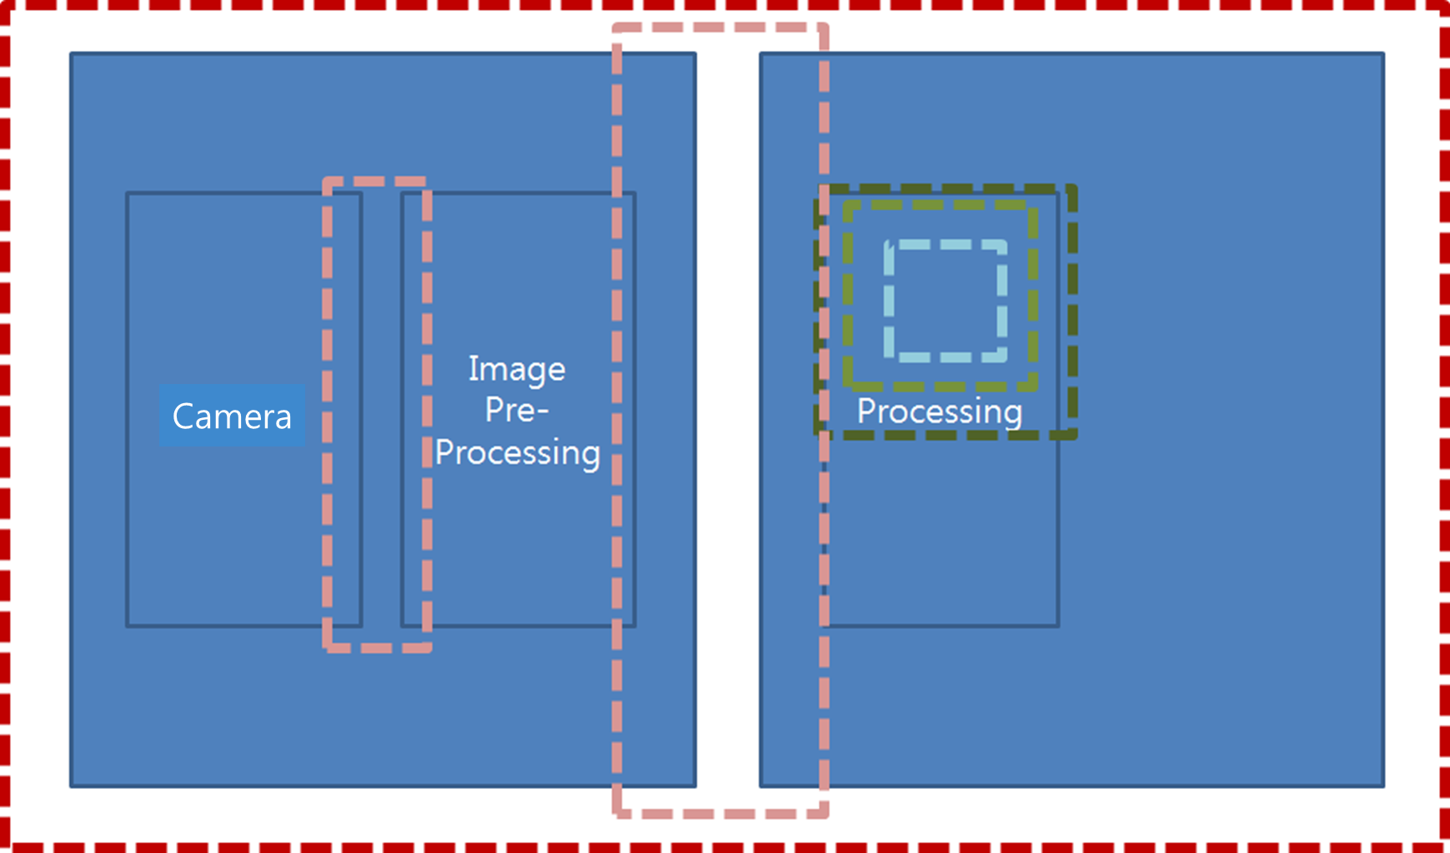
Sample B

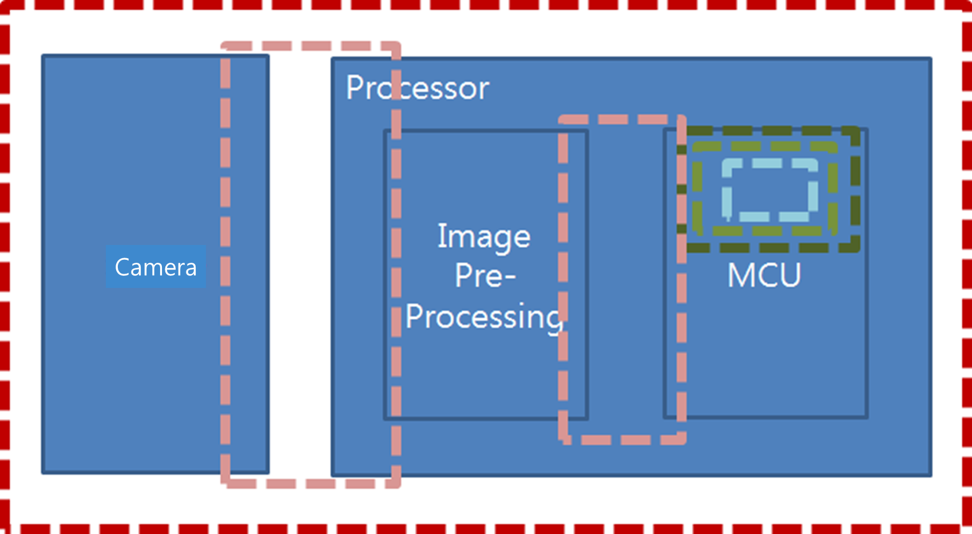
Sample C
Figure 1-2 Test Scope

The test elements of the system elements are shown in Table 1.
Category | System Element | Test Scope | Description
HW | Camera | O | Developed by LGE
HW | Imager | X | Developed by Onsemi  The system elements developed by Onsemi are replaced by the HW test result report, and inspected during system integration testing
HW | AP (Sky runner) | X | Developed by NXP  The system elements developed by NXP are replaced by the HW test result report, and inspected during system integration testing
HW | HuD sensor | O
SW | CPA, APTR – Object recognition | X | Collaborated with LGE and Stradvision to develop  System elements developed by Stradvision are replaced with SW Unit test result report, , and inspected during SW integration testing
SW | LDP, LKA – Lane recognition | O | Developed by LGE
SW | TSA – TSR  Traffic signal recognition | X | Developed by HAGL
SW | IHC - Light | X | Developed by HAGL
SW | QoS | O | Developed by LGE
SW | Calibration | O | Developed by LGE
SW | Virtual Map | O | Developed by LGE
SW | EVM | O | Developed by LGE
SW | OS (Green Hills) (TBD) | X | Developed at Green Hills  The system elements developed by Green Hills were replaced by SW Unit test result report and inspected during SW integration testing
SW | AUTOSAR | X | Developed at Vector  The system elements developed by Vector were replaced by SW Unit test result report and inspected during SW integration testing
Table 1-1 System Elements

SW designs and elements (or components) are described in the SW design document.
The following table describes the system elements to be tested in each test area.

Category | SW Components | Description
Tier2 |  | SW Integration Test, System Integration Test and System Test  Exclude SW Unit Test (Replaced with company verification report)
Tier2 | OS  Open Source | System Integration Test and System Test  Except SW Unit Test and SW Integration Test (Replaced with company verification report)
LG development team |  | Test all areas
delete |  | Exclude test
 |  | Exempt from testing (can not be used for Chinese)
Table 1-2 SW Components & Major Function

Please refer to the SW Unit Test Plan when testing the SW structure
(http://val.lge.com/ivi/svn/DAI_MPC5_5/trunk/03_SW_Engineering/04_Test/02_SW_Unit_Veification/01_SW_Unit_Verification_Plan)
Please refer to the SW Integration Test Plan for SW integration test.
(http://val.lge.com/ivi/svn/DAI_MPC5_5/trunk/03_SW_Engineering/04_Test/03_SW_Integration_Test/01_SW_Integration_Test_Plan)
Please refer to the SW Test Plan for SW requirement test.
(http://val.lge.com/ivi/svn/DAI_MPC5_5/trunk/03_SW_Engineering/04_Test/04_SW_Qualification_Test/01_SW_Qualification_Test_Plan)
Please refer to the System Integration Test Plan for system structure test.
(http://val.lge.com/ivi/svn/DAI_MPC5_5/trunk/03_SW_Engineering/04_Test/05_System_Integration_Test/01_System_Integration_Test_Plan)
Please refer to the System Test Plan for System requirement test.
(http://val.lge.com/ivi/svn/DAI_MPC5_5/trunk/03_SW_Engineering/04_Test/06_System_Qualification_Test/01_System_Qualification_Test_Plan)

Assumptions and constraints
Create test-related assumptions or constraints

The hardware will be changed three times (Sample A, B, and C).
NXP's chip SkyRunner is available for the final sample C.

Organizational Constraints
Create organizational constraints for testing

The VS Smart development test team is responsible for the system test.
The VS Smart Test Design Team is responsible for System Integration testing.
The VS Smart Test Environment Team is responsible for SW testing.
The VS Smart ADAS forward camera team is responsible for SW Unit testing and SW integration testing.

Project Constraints
Create test-related project constraints
Constraints on test schedules (example)
Constraints on the test cycle (example)
Constraints on test personnel (example)
Constraints on the test environment (example)
Constraints on test budgets (example)

The development schedule is developed based on the V model 9 times.
The goal of functional test completion is Release 7.
This project is LG's first ADAS forward camera for Daimler. LGE needs to invest in the test environment.

Contractual Constraints
Create constraints related to testing

Regulatory / Legal Constraints
Create constraints and legal constraints related to the test-related standards

Must comply with A-SPICE CL3 and NCAP 2020+ regulations.

Testing Communication

Stakeholders
Write about the person in charge of the test and the related department personnel.
If it has already been created in the Project Master Plan (PMP), it will be referred to as the document link (directory rather than the specific version of the document)

See PMP ^{Project Master Plan} .
(http://val.lge.com/ivi/svn/DAI_MPC5_5/trunk/02_Management/04_Project_Management)

Communication plan
Communication with the development team, communication with the development testing team, and relationship between DCV / NEO / FPT.
If it has already been created in the Project Master Plan (PMP), it will be referred to as the document link (directory rather than the specific version of the document)

See PMP ^{Project Master Plan}
(http://val.lge.com/ivi/svn/DAI_MPC5_5/trunk/02_Management/04_Project_Management

Risk Register
The risk associated with the test should be derived from the predefined risk in the project.
If there is no definition, do not write it as optional.

Project Risks
※ Risk = Likelihood × Impact
※ Likelihood: 1 (Low), 2 (Medium), 3 (High) / Impact: 1 (Low), 2 (Medium), 3 (High)
ID | Project Risk | Likelihood | Impact | Risk Score | Mitigation Activities
P1 | Lack of testing skills
P2 | Labor shortage
P3 | Education Issue
P4 | Low quality design
P5 | Delivery delay of Chipset etc.
P6 | Supply and demand problems of suppliers
P7 | Not enough testing schedule
P8 | Delayed build of test environment
P9 | Development delay of test data
P10 | …

Table 3-3 Project Risks

Product Risks
※ Risk = Likelihood × Impact
※ Likelihood: 1 (Low), 2 (Medium), 3 (High) / Impact: 1 (Low), 2 (Medium), 3 (High)
ID | Project Risk | Likelihood | Impact | Risk Score | Mitigation Activities
R1 | AAA (Complex features)
R2 | BBB (New development function)
R3 | CCC (Src Code Large Function)
R4 | DDD (Highly technical skill)
R5 | EEE (Latest technology applied)
R6 | FFF (Poor developer experience)
R7 | GGG (High visibility to external)
R8 | HHH (Safety can be a threat)
R9 | III (If the intensity is intense - the intensity of light / sound)
R10 | JJJ (A big blow to the company image)
R11 | …

Table 3-4 Product Risks

Test Strategy
Write about the test strategy
For detailed test strategy for each test area, refer to separate test plan document for each test area.

The A-SPICE PAM 3.0 document defines the following for each test area for each development area.
- System testing for system requirements
- For system design, system integration test
- Software testing for software requirements
- For software designs, the software integration test
- For Software Unit, Software Unit Test

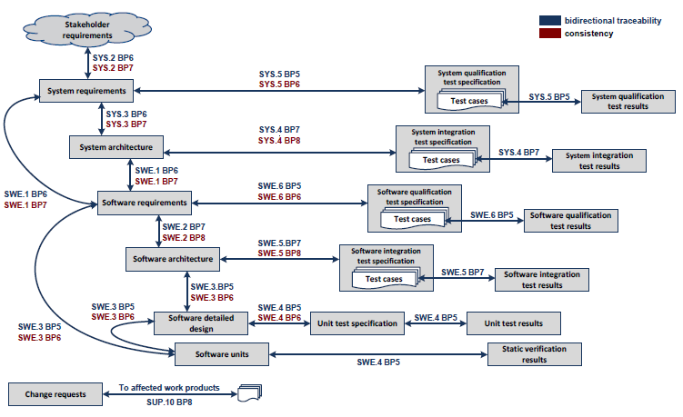
Figure 4-3. Bidirectional Traceability and Consistency of A-SPICE PAM 3.0

This project must comply with the A-SPICE test areas described above.
The development schedule will be 9 releases and the goal is release 7.
The period for each release is 3 months. For this reason, the Software Unit exam must be initiated and completed within the implementation schedule. Software testing, system integration testing, and system testing are conducted simultaneously for four weeks and summarize and share the results report for one week.
For details, refer to the document for each examination area.

Test Process
Write about the test procedure

The figure below shows the test method.
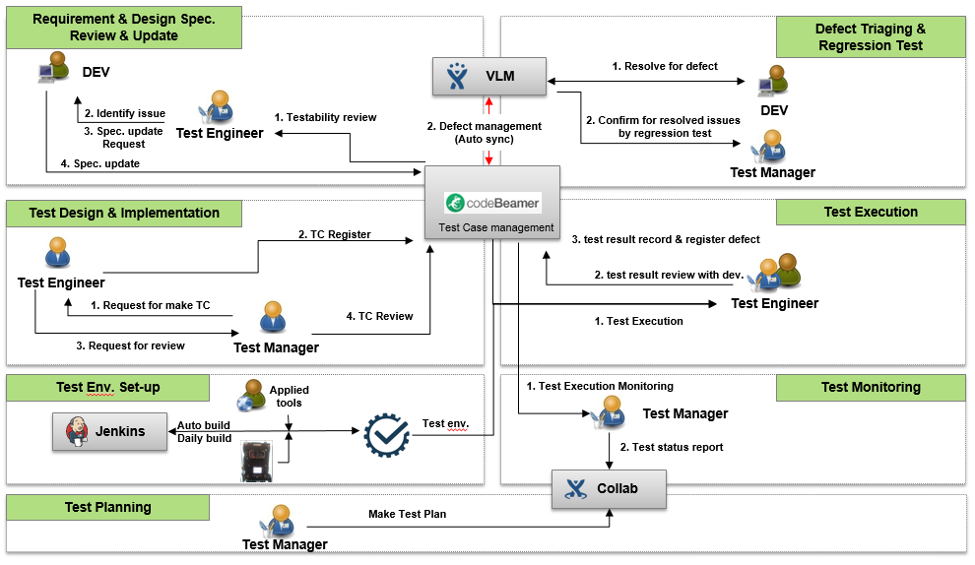
Figure 4-4. Test Process

Test Deliverables

Test Cases
Write about Test Case
For each test case, refer to the separate Test Case document for each test area

The table below represents the repository of Test Cases for each test area.
Test Level | Test Cases
Software Unit Verification | Software Unit Verification Test Cases  http://val.lge.com/ivi/svn/DAI_MPC5_5/trunk/03_SW_Engineering/04_Test/02_SW_Unit_Veification/02_SW_Unit_Verification_Case
Software Integration and Integration Test | SW Integration Test Cases  http://val.lge.com/ivi/svn/DAI_MPC5_5/trunk/03_SW_Engineering/04_Test/03_SW_Integration_Test/02_SW_Integration_Test_Case
Software Qualification Test | SW Qualification Test Cases  http://val.lge.com/ivi/svn/DAI_MPC5_5/trunk/03_SW_Engineering/04_Test/04_SW_Qualification_Test/02_SW_Qualification_Test_Case
System Integration and Integration Test | System Integration Test Cases  http://val.lge.com/ivi/svn/DAI_MPC5_5/trunk/03_SW_Engineering/04_Test/05_System_Integration_Test/02_System_Integration_Test_Case
Sysetm Qualificaiton Test | System Qualification Test Cases  http://val.lge.com/ivi/svn/DAI_MPC5_5/trunk/03_SW_Engineering/04_Test/06_System_Qualification_Test/02_System_Qualification_Test_Case
Table 4-5 Test Cases

Test Results Report
Write about the test result report
The results report for each test area refers to a separate report of the results report for each test area

The table below represents the repository of test results reports for each test area.

Test Level | Report
Software Unit Verification | Static Analysis Test Results  http://val.lge.com/ivi/svn/DAI_MPC5_5/trunk/03_SW_Engineering/04_Test/02_SW_Unit_Veification/04_SW_Unit_Verification_Static_Analysis_Report  Software Unit Verification Test Results  http://val.lge.com/ivi/svn/DAI_MPC5_5/trunk/03_SW_Engineering/04_Test/02_SW_Unit_Veification/03_SW_Unit_Verification_Report
Software Integration and Integration Test | SW Integration Test Results  http://val.lge.com/ivi/svn/DAI_MPC5_5/trunk/03_SW_Engineering/04_Test/03_SW_Integration_Test/03_SW_Integration_Test_Report
Software Qualification Test | SW Qualification Test Results  http://val.lge.com/ivi/svn/DAI_MPC5_5/trunk/03_SW_Engineering/04_Test/04_SW_Qualification_Test/03_SW_Qualification_Test_Report
System Integration and Integration Test | System Integration Test Results  http://val.lge.com/ivi/svn/DAI_MPC5_5/trunk/03_SW_Engineering/04_Test/05_System_Integration_Test/03_System_Integration_Test_Report
Sysetm Qualificaiton Test | System Qualification Test Results  http://val.lge.com/ivi/svn/DAI_MPC5_5/trunk/03_SW_Engineering/04_Test/05_System_Integration_Test/03_System_Integration_Test_Report
Table 4-6 Test Results Report

Test Plan
Write about the test plan
For each test area-specific test plan, refer to separate test plan document for each test area

The table below represents the repository of test plans for each test area.
Test Level | Test Plan
Software Unit Verification | System Qualification Test Plan  (http://val.lge.com/ivi/svn/DAI_MPC5_5/trunk/03_SW_Engineering/04_Test/06_System_Qualification_Test/01_System_Qualification_Test_Plan)
Software Integration and Integration Test | System Integration and Integration Test Plan  (http://val.lge.com/ivi/svn/DAI_MPC5_5/trunk/03_SW_Engineering/04_Test/05_System_Integration_Test/01_System_Integration_Test_Plan)
Software Qualification Test | Software Qualification Test Plan  (http://val.lge.com/ivi/svn/DAI_MPC5_5/trunk/03_SW_Engineering/04_Test/04_SW_Qualification_Test/01_SW_Qualification_Test_Plan)
System Integration and Integration Test | Software Integration and Integration Test Plan  (http://val.lge.com/ivi/svn/DAI_MPC5_5/trunk/03_SW_Engineering/04_Test/03_SW_Integration_Test/01_SW_Integration_Test_Plan)
Sysetm Qualificaiton Test | Software Unit Verficiation Plan  (http://val.lge.com/ivi/svn/DAI_MPC5_5/trunk/03_SW_Engineering/04_Test/02_SW_Unit_Veification/01_SW_Unit_Verification_Plan)
Table 4-7 Test Plans

Reviews

Testability Review
Requirements Create the necessary processes, tools, and checklists for the Testability Review
Write Review Techniques (Walkthrough / Technical Review ...) to be applied at the time of technical document review

The table below explains how to review the testability.
Test managers and test engineers for each test area use the checklist to review the development team and its documentation (CodeBeamer).

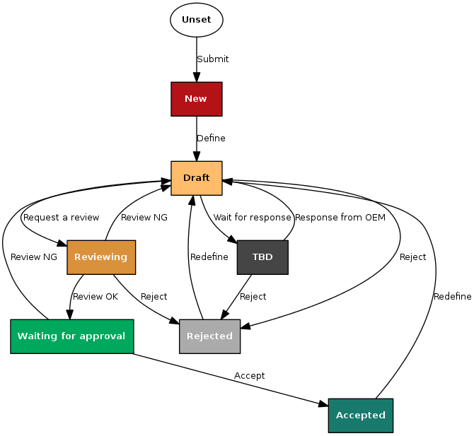
Figure 4-5. Requirements Testability Review

For details, refer to each test plan.

Test Case Conformity Review
Create the necessary processes, tools, and checklists for the Test Case Conformity Review
Write Review Techniques (Peer-review ...) to be applied to Test Case Review

For details, please refer to the test plan for each test area.

Test Design Techniques

Software Code Review (Example)
Write Software Code Review Method

Refer to the Software Unit Test Plan for software code review options.
(http://val.lge.com/ivi/svn/DAI_MPC5_5/trunk/03_SW_Engineering/04_Test/06_System_Qualification_Test/01_System_Qualification_Test_Plan).

Static Testing (Example)
Write a static test execution method

Refer to the Software Unit Test Plan for corrective testing.
(http://val.lge.com/ivi/svn/DAI_MPC5_5/trunk/03_SW_Engineering/04_Test/06_System_Qualification_Test/01_System_Qualification_Test_Plan).

Specification Based Testing
Create a specification-based test run

Test Technique | Applicable (Y or N) | Remarks
Equivalence Partitioning
Boundary Value Analysis
Decision Table Testing
State Transition Testing
Combinatorial Testing
Scenario Testing
Test Techniques of Specification-Based Testing

The table below describes the specification-based testing techniques for each test area.
For details, refer to the test plan for each test area.

Test Technique | Test Level
Equivalence Partitioning | SWUT, SWIT, SWT, SysIT, SysT
Boundary Value Analysis | SWUT, SWIT, SWT, SysIT, SysT
Decision Table Testing | N/A
State Transition Testing | SWIT, SWT, SysIT, SysT
Combinatorial Testing | N/A
Scenario Testing | SWT, SysT
Table 4-8 Test Techniques of Specification Based Testing

State Transition Testing (Example)
If you perform State Transition Testing for critical ABC functions at risk, write the appropriate content

Scenario Testing (Example)
Describe how to perform the scenario test
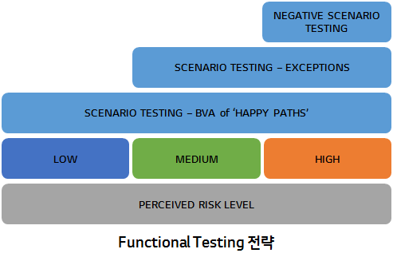
(Example Illustration)

Structure Based Testing
Create a structure-based test run
Test Technique | Applicable (Y or N) | Remarks
Statement Testing
Decision Testing
Branch Testing
Branch Condition Testing
(All) Path Testing
Control Flow Testing
Test Techniques of Structure-Based Testing

The following table describes the structure-based test techniques for each test area.
Please refer to each test plan for details.

Test Technique | Test Level
Statement Testing | SWUT, SWIT
Decision Testing | N/A
Branch Testing | SWUT
Branch Condition Testing | N/A
(All) Path Testing | N/A
Control Flow Testing | SWIT
Table 4-9 Test Techniques of Structured Based Testing

Experience Based Testing
Create an experience-based test run

Test Technique | Applicable (Y or N) | Remarks
Ad-hoc Testing
Exploratory Testing
Scripted Testing
Test Techniques of Experience-Based Testing

The following table describes the experience-based testing techniques for each test area.
Please refer to each test plan for details.

Test Technique | Test Level
Ad-hoc Testing | SWT, SysT
Exploratory Testing | SWT
Scripted Testing | SWIT, SWT, SysIT, SysT
Table 4-10 Test Techniques of Experience Based Testing

Ad-hoc Testing (예시)
Write about how to perform Ad-hoc tests

Exploratory Testing (예시)
Describe how to perform an exploratory test
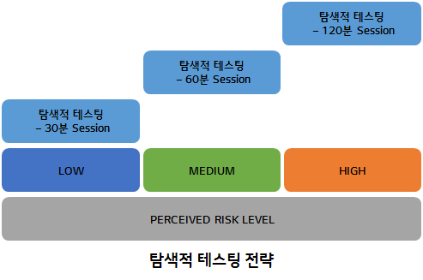
Exploratory testing
Exploratory testing
Exploratory testing
Exploratory testing
min Session
min Session
min Session
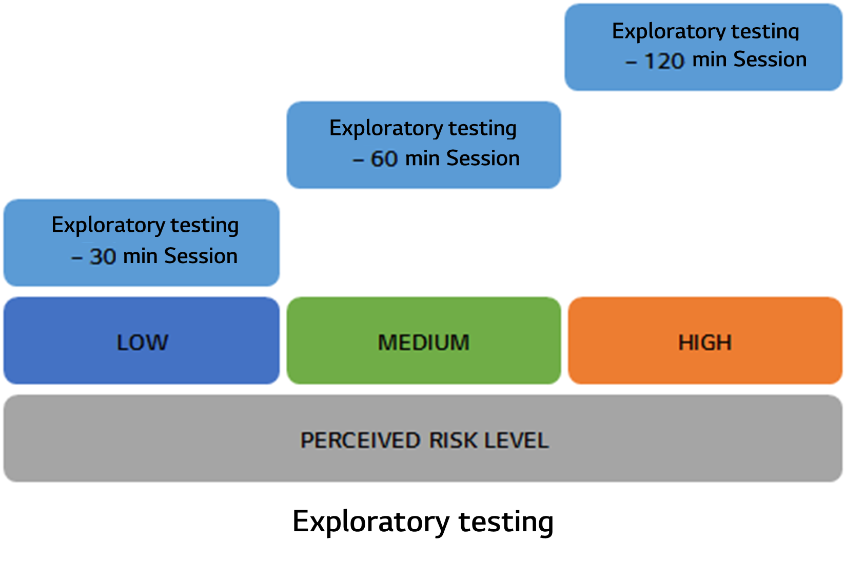

Qualification Testing

Performance (Example)
Create a test plan for the main and minor characteristics of ISO 25010 defined by the parent

Accessibility (Example)
Create a test plan for the main and minor characteristics of ISO 25010 defined by the parent

Test Entry / Completion Criteria

Entry Criteria
Prepare test entry conditions for each test area

Test Level | Entry Criteria
Software Unit Verification | Every code commit  SDD Documents  SW unit implementation complete
Software Integration and Integration Test | Completed Testability Review and Test Case Design Review  Completed Test Frame work  Development Team's Software Code Freeze  Completed SW Unit Test
Software Qualification Test | SW release for test  Completed SW Unit Test
System Integration and Integration Test | System release including HW and SW
Sysetm Qualificaiton Test | New release for OEM Delivery  SW changes due to new CRs and improvements
Table 4-11 Entry Criteria

Completion Criteria
Create test termination conditions for each test area

Test Level | Completion Criteria
Software Unit Verification
Software Integration and Integration Test
Software Qualification Test
System Integration and Integration Test
Sysetm Qualificaiton Test
Table 4-12 Completion Criteria

CCB Completion Criteria
Write about the CCB termination condition

Upon completion of the function, changes are managed through the CCB and its completion condition.
Test Level | CCB Completion Criteria
Software Unit Verification
Software Integration and Integration Test
Software Qualification Test
System Integration and Integration Test
Sysetm Qualificaiton Test
Table 4-13 CCB Completion Criteria

Metrics to be collected
Please refer to the measurement report.
(http://val.lge.com/ivi/svn/DAI_MPC5_5/trunk/02_Management/10_Quality_Measurement).

The Metrics of Measurement Analsysis
Write about the measurement index during the test

For details, refer to each test plan.
Test Level | The Metrics of Measurement Analsysis
Software Unit Verification | Equivalence Partitioning  Boundary Value Analysis  Statement Coverage  Branch Coverage
Software Integration and Integration Test | SW Interface Coverage
Software Qualification Test | SW Requirements Coverage
System Integration and Integration Test | HSI Hardware and Software Interface Coverage
Sysetm Qualificaiton Test | System Requirements Coverage
Table 4-14 The Metrics of Measurement Analysis

The Metrics of Test Cases Develoment Plan
Write about the test case preparation plan index

For details, refer to each test plan.

Test Level | The Metrics of Test Cases Develoment Plan
Test Level | R1 | R2 | R3 | R4 | R5 | R6 | R7
Software Unit Test | 30% | 40% | 55% | 60% | 90% | 100%
Software Integration and Integration Test | 10% | 20% | 30% | 50% | 70% | 90% | 100%
Software Test | N/A | N/A | 30% | 50% | 70% | 90% | 100%
System Integration and Integration Test | N/A | N/A | 50% | 70% | 90% | 10% | 100%
Sysetm Test | N/A | N/A | 30% | 50% | 70% | 90% | 100%
Table 4-15 The Metrics of Test Cases Develoment Plan

Retesting and Regression Testing
Set up the regression testing cycle (for example, perform the retesting three times and then perform the regression testing) and set up the retesting cycle

In case of fail in test case, in case of serious case, retest should be performed.
During regression testing, you should retest the associated test cases and perform a regression test.
For details, refer to each test plan.

Test Level | Retesting and Regression Testing
Software Unit Verification | Software Unit Test Plan  (http://val.lge.com/ivi/svn/DAI_MPC5_5/trunk/03_SW_Engineering/04_Test/02_SW_Unit_Test/01_SW_Unit_Test_Plan)
Software Integration and Integration Test | Retesting - When the corresponding test object change occurs, only the module related to the interface executes the test.  Regression Testing - When each test object test is completed, the regression test proceeds  See the Software Integration and Integration Test Plan in more detail  (http://val.lge.com/ivi/svn/DAI_MPC5_5/trunk/03_SW_Engineering/04_Test/03_SW_Integration_Test/01_SW_Integration_Test_Plan)
Software Qualification Test | Software Test Plan  (http://val.lge.com/ivi/svn/DAI_MPC5_5/trunk/03_SW_Engineering/04_Test/04_SW_Test/01_SW_Test_Plan)
System Integration and Integration Test | System Integration and Integration Test Plan  (http://val.lge.com/ivi/svn/DAI_MPC5_5/trunk/03_SW_Engineering/04_Test/05_System_Integration_Test/01_System_Integration_Test_Plan)
Sysetm Qualificaiton Test | Retesting : The test case that identified defect are perrformed and check whehter the defect corrected.  Regression Testing : Verify the TC in the Sub function of the TC where the defect occurred  See the System Test Plan in more detail  (http://val.lge.com/ivi/svn/DAI_MPC5_5/trunk/03_SW_Engineering/04_Test/06_System_Test/01_System_Test_Plan)
Table 4-16 Retesting and Regression Testing

Test Tools

SW Testing Tools
Write about the SW tools used in the test.

For details, refer to each test plan.

Test Level | SW Testing Tools
Software Unit Verification | OS : Ubuntu 14.04.5 LTS 64-bit  Compiler : gcc 4.8.1  Gerrit v2.13.7 for Software Code Review  Coverity v8.6 for Static Testing  Controller Tester v2.9.2 for Specification Based Testing & Structured Based Testing
Software Integration and Integration Test | OS : Ubuntu 14.04.5 LTS 64-bit  Compiler : gcc 4.8.1
Software Qualification Test | OS : Windows 7 64-bit  CANoe  Logger  Trace32
System Integration and Integration Test
Sysetm Qualificaiton Test | EB ADTF Development v2.13.2  EB ADTF Runtime v2.13.2  Softing DTS Monaco v8.0 for data collection  HAGL Annostation v2.0 or data labelling  HAGL Datastation for data & test management  dSpace ControlDesk v6.0, dSpace AutomationDesk v2017a, Mathwork MATLAB v6.1, and IPG CarMaker HIL Pro for functional test, stability test, fail-safe test  Vector CANoe v10.0, and Vector CANoe.Option DiVA v4.0 for diagnostic test  Vector CANape v15.0 for XCP test  Vector vFlash v3.1 for reprogramming test
Table 4-17 SW Testing Tools

HW Testing Tools
Write about the HW tools used in the test.

For details, refer to each test plan.

Test Level | HW Testing Tools
System Integration and Integration Test | Osiloscope  Signal Analyzer  Multimeter
Sysetm Qualificaiton Test | bPlus BRICK CORE COM MILOG, bPlus BRICK STORAGE, bPlus MID, Power Box, and Star Coorperation FlexDevice-L for data collection – measurement system  IBEO Lidar Sensor (Lux 8), OxTR RTK DGPS (RT Range S), and Velodyne Lidar Sensor (HDL-64E S2) for data collection – sensor  bPlus b-HIL45 for DB HIL test  Driving Robot  InnoX ADAS HIL Rack, and InnoX Monitor HIL Bench for functional test, stability test, and fail-safe test  Vector VN8970 for diagnostic test, XCP test, and reprogramming test  Cyclist Dummy  OxRT RTK DGPS  Pedestrian Dummy  Test Workstation  Vehicle Dummy
Table 4-18 HW Testing Tools

Configuration Management
Create a configuration management plan
If it has already been created in the CMP (Configuration Management Plan), refer to the document.

See the configuration management documentation.
(http://val.lge.com/ivi/svn/DAI_MPC5_5/trunk/02_Project%20Management/02_Plan/08_Configuration_Management_Plan)

Staffing

Roles, activities, and responsibilities
Write about roles, activities, and responsibilities
If you have already created a Project Master Plan (PMP) document,다

See PMP (Project Master Plan).
(http://val.lge.com/ivi/svn/DAI_MPC5_5/trunk/02_Project%20Management/02_Plan/01_Project_Management_Plan/)

Training needs
Describe the need for training to improve the work skills of test staff
If it has already been created in the Competence Management document, refer to it.

See PMP (Project Master Plan)
(http://val.lge.com/ivi/svn/DAI_MPC5_5/trunk/02_Management/06_Competence_Management)

Schedule
Complete the test schedule, including the development schedule
For detailed test schedule for each test area, refer to the corresponding test plan document
If the schedule has already been detailed in the Feature Release Plan or WBS, refer to the relevant document

The development schedule will be 9 releases and the goal is release 7.
The period for each release is 3 months. For this reason, the Software Unit exam must be initiated and completed within the implementation schedule. Software testing, system integration testing, and system testing are conducted simultaneously for four weeks and summarize and share the results report for one week.
For details, refer to each test plan.

Test Level | Schedule | Activities
Software Unit Verification | Start at the same time as the development period and end up 5 weeks before release to the test team
Software Integration and Integration Test | Duration 4 weeks  : The basic software integration test is completed before release to the test team, but the detailed software integration test is completed within the next two weeks
Software Qualification Test | Duration 5 weeks  : 4-week test and 1-week test results
System Integration and Integration Test | Duration 5 weeks  : 4-week test and 1-week test results
Sysetm Qualificaiton Test | Duration 5 weeks  : 4-week test and 1-week test results
Table 6-19 Schedule

